**Jenkins launch Steps**

**To start Jenkins from command line**

1. Open command prompt
2. Go to the directory where your war file is placed and run the following command:
3. In my case it got installed at C:\Program Files (x86)\Jenkins
4. Type following command

java -jar jenkins.war

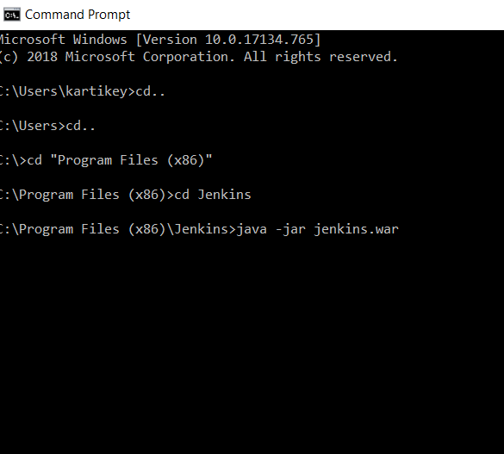

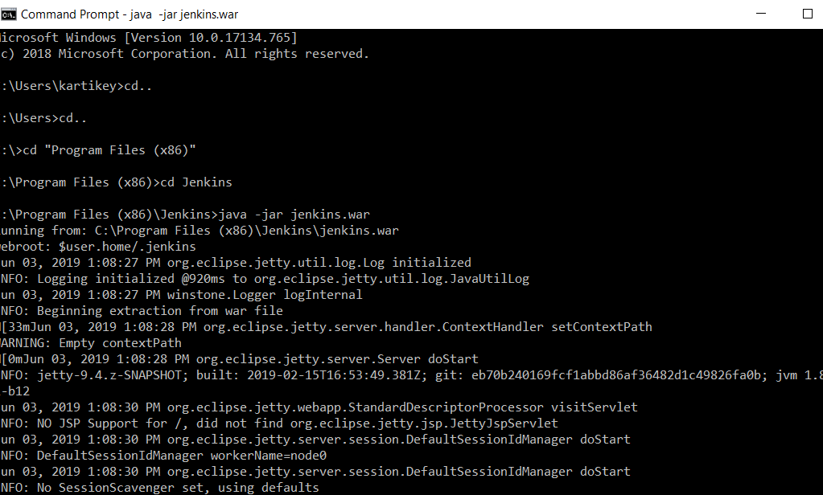

Once completed open your browser and launch Jenkins through following url

[http://localhost:8080](http://localhost:8080/)

Create account and you are good to go with Jenkins